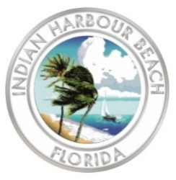
RFQ #2025-06
EVALUATION Committee MEETING
City of Indian Harbour Beach, Florida
Wednesday, November 12, 2025, at 2:00 PM
Council Chamber | 2055 South Patrick Drive
Minutes
Evaluation Committee
David Lewis, MHA, NRP, CFO, Fire Chief
Orrie Covert, Assistant to the City Manager
John W. Coffey, ICMA-CM, City Manager

- Call to order
- City Manager Coffey, ICMA-CM, called the meeting to order promptly at 2:00 p.m.

- Pledge of allegiance
- City Manager Coffey, ICMA-CM, led the Pledge of allegiance to the American flag.

- Roll call
- City Manager Coffey, ICMA-CM, called roll with all members in attendance.

- Election of a Chairman
- City Manager Coffey, ICMA-CM, motioned for Fire Chief Lewis to be chairman, quickly seconded by Assistant to the City Manager Covert, approved 3-0.

- Opening of Qualification Statements
- Chairman Lewis opened the qualification statements.

- Establishment of the format for the oral interviews nd selection of firms to participate
- Discussion format. Consensus to use 20-minute interviews with a ten-minute break in between
- Consensus to use the standard scoring form
- Consensus to allow firms to appear on November 21, 2025, if they cannot make the advertised November 20, 2025 date

- Announcement of the next meeting date and time
- Thursday, November 20, 2025, at 2:00 pm

- Adjournment
- Chairman Lewis adjourned the meeting at 2:39 p.m.

