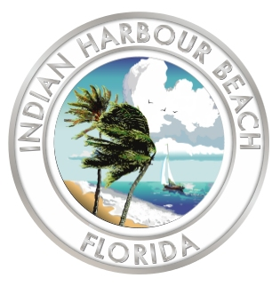
Indian Harbour Beach City Hall
2055 South Patrick Drive
Indian Harbour Beach, FL 32937
(321) 773-3181 (Phone)
(321) 773-5080 (Fax)

RFP #2025-01: City Hall Baffle Box Construction Services

Evaluation Committee Meeting Agenda

9:00 a.m. May 27, 2025

LTC Norman C. Hayes and Marilyn C. Hayes
City Hall Council Chamber

- Call to order
- Meeting called to order at 9:01 AM.

- Roll call
- Dominic Hamilton - Present
- Todd Scaldo - Present
- Orrie Covert - Present

- Selection of a Chairman
- Dominic Hamilton nominated Todd Scaldo to be chairman. Motion seconded by Orrie Covert.

- Opening of proposals
- Universal - $758,854.39
- BDI - $776,750.00
- Cathcart - $3,019,866.90

- Announcement of next meeting date and time
- 9 AM Wednesday, June 4th

- Adjourn
- Chairman Scaldo adjourned the meeting at 9:09 AM.

