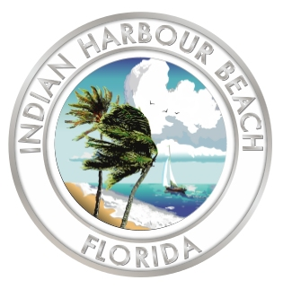
Indian Harbour Beach City Hall
2055 South Patrick Drive
Indian Harbour Beach, FL 32937
(321) 773-3181 (Phone)
(321) 773-5080 (Fax)

RFP #2025-01: City Hall Baffle Box Construction Services

Evaluation Committee Meeting Agenda

9:00 a.m. June 4, 2025

LTC Norman C. Hayes and Marilyn C. Hayes
City Hall Council Chamber

- Call to order
- Meeting called to order at 9:01 a.m.

- Pledge of allegiance

- Roll call
- Dominic Hamilton - Present
- Todd Scaldo - Present
- Orrie Covert - Present

- Evaluation of proposals
- Universal – 221
- BDI – 240
- Cathcart - 170

- Public Comment
- N/A

- Adjourn
- Chairman Scaldo adjourned the meeting at 9:15 a.m.

