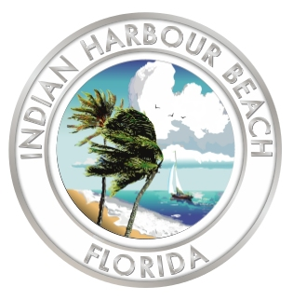
Indian Harbour Beach City Hall
2055 South Patrick Drive
Indian Harbour Beach, FL 32937
(321) 773-3181 (Phone)
(321) 773-5080 (Fax)

RFP #2025-01: City Hall Baffle Box Construction Services

Evaluation Committee Meeting Agenda

9:00 a.m. May 27, 2025

LTC Norman C. Hayes and Marilyn C. Hayes
City Hall Council Chamber

- Call to order

- Roll call

- Selection of a Chairman

- Opening of proposals

- Announcement of next meeting date and time

- Adjourn

